Construction of Representative LTTR Tree

1. CD Hit at 95%
biolinux@biolinux-VirtualBox[biolinux] cd-hit -i galaxy_no_duplicates.fa -o seqs -c 0.95 -n 5 -M 0
================================================================

2. Muscle Alignment
biolinux@biolinux-VirtualBox[Creating_Fig1] muscle -in seqs -phyiout reps_muscle

3. Phyml Tree using
http://www.atgc-montpellier.fr/phyml/, screenshot showing parameters applied.
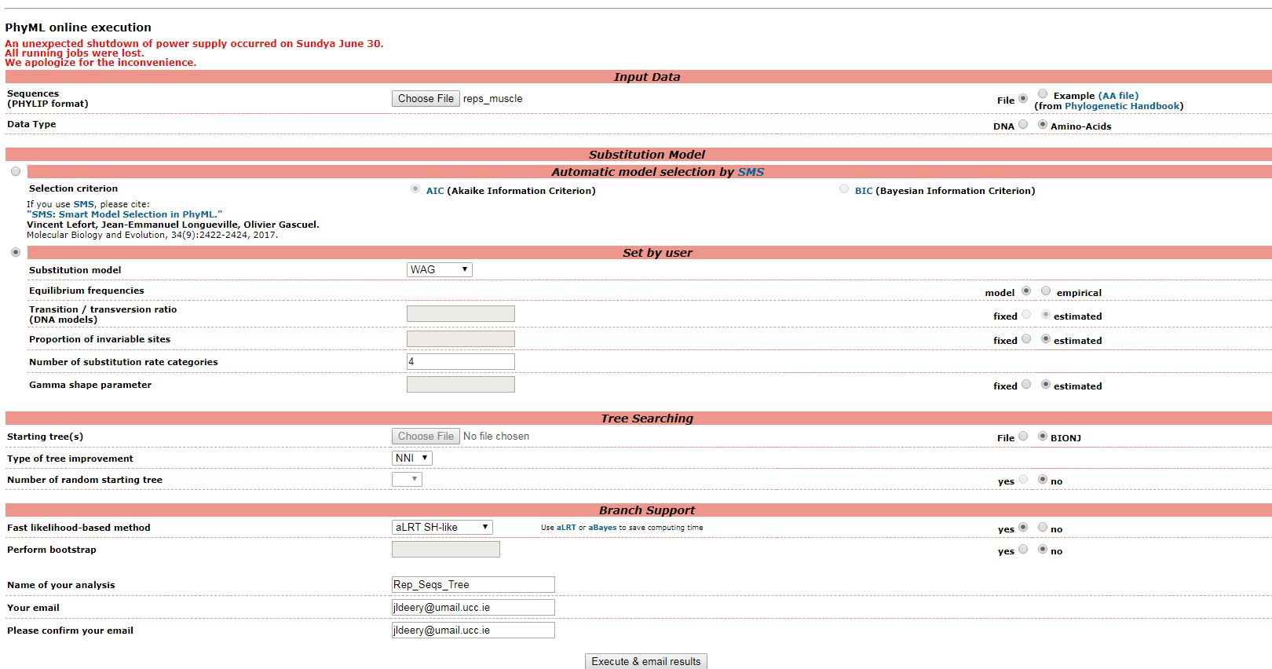

4. Visualise and export using web-based tool Interactive Tree Of Life https://itol.embl.de/

